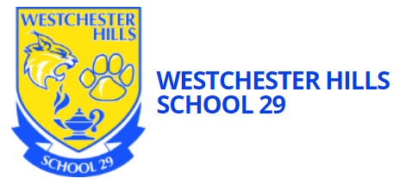

**Welcome to Westchester Hills School 29**! My name is Mrs. Pellegrino and I’m so excited to welcome your child into my class this year. I have been at School 29 for over 10 years and treat each student as I would my own children. I believe it creating a love of school and nurturing each child’s individual needs and strengths. We are excited for a new year and look forward to getting to know you and your child.

Please be sure your child has a bookbag large enough for a plastic folder. Our class supply list will be sent home with a complete list of needed supplies. I will also be sending home a sample schedule.

****Please provide a list of allergies or any special diets that your child may have. Please be sure to label your child’s personal belongings, such as lunchboxes or jackets. Breakfast, lunch and snack are part of our daily schedule. Please send your child with a healthy snack each day including a beverage. Also, please label the snack in a separate bag from their lunch, if you are sending one. Breakfast and lunch are provided everyday by Yonkers Public Schools. You can find the menu on the district webpage. <https://www.yonkerspublicschools.org/Page/216> If your child will not eat what is on the menu for the day, please be sure to send something in for them to eat as there are no other options. We do have a microwave to warm up food, but please send it ready to serve.

I am excited to work with our family and ensure you that we will provide a safe, nurturing, structured and stimulating environment to help your child succeed. I thank you in advance for your cooperation and support.